H.T No
Regulations:
A18

Sreenidhi Institute of Science and Technology
(An Autonomous Institution)
Code No: 7BC03 Date: 06-July-2021 (FN)

B.Tech I-Year I- Semester External Examination, July-2021 (Supplementary)
ENGINEERING MECHANICS (ME)

Time: 3 Hours Max.Marks:70

Note: a) No additional answer sheets will be provided.
b) All sub-parts of a question must be answered at one place only, otherwise it will not be valued.
c) Missing data can be assumed suitably.

ANSWER ANY 5 OUT OF 8 QUESTIONS. EACH QUESTION CARRIES 14 MARKS.

Bloom's Cognitive Levels of Learning (BCLL)

Remember | L1 | Apply | L3 | Evaluate | L5
Understand | L2 | Analyze | L4 | Create | L6

 |  |  | BCLL | CO(s) | Marks
1. | a) | A vessel is pulled by two ropes as shown in figure. Obtain the resultant force applied on the vessel if the tension on each rope is 1000 N.  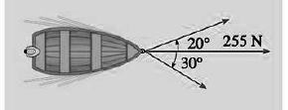 | L3 | CO1 | [14M]
2. |  | An inclined truss shown in Figure is loaded as shown. Determine the nature and magnitude of the forces in the members BC, GC and GF of the truss.  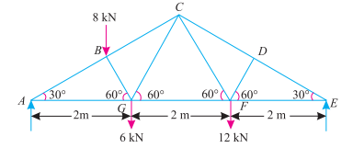 | L5 | CO2 | [14M]
3. |  | A load of 500 N is lying on an inclined plane, whose inclination with the horizontal is 30°. If the coefficient of friction between the load and the plane is 0.4, find the minimum and maximum horizontal force, which will keep the load in equilibrium. | L3 | CO3 | [14M]
4. |  | Find the moment of inertia of a rectangular section 30 mm wide and 60 mm deep about X-X axis and Y-Y axis. | L3 | CO4 | [14M]
5. |  | The angular acceleration of a fly wheel is given by α =8 −t, where α is in radians S ² and t is in seconds. If the angular velocity of the flywheel is 42 rad/s at end of 6 seconds, determine initial angular velocity and the number of revolutions made during the 6 seconds. | L5 | CO5 | [14M]
6. | a) | A truck of mass 15 tonnes travelling at 1.6 m/s impacts with a buffer spring, which compresses 1.25 mm per kN. Find the maximum compression of the spring. | L5 | CO6 | [7M]
 | b) | A ball of mass 1 kg moving with a velocity of 2 m/s impinges directly on a ball of mass 2 kg at rest. The first ball, after impinging, comes to rest. Find the velocity of the second ball after the impact and the coefficient of restitution. | L5 | CO6 | [7M]
7. | a) | Find the forces in the BD, CE and FG members of the truss shown in figure using method of sections.  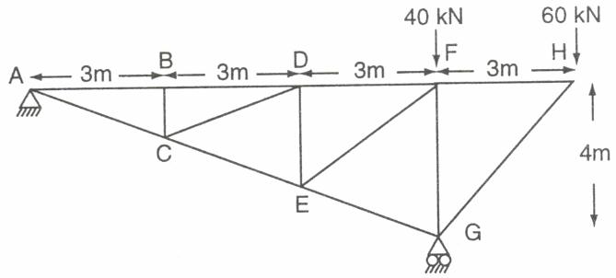 | L5 | CO1 | [7M]
 | b) | A uniform ladder of weight 300 N rests against a smooth vertical wall and a rough horizontal floor making an angle of 45° with the horizontal. Find the force of friction at floor using the method of virtual work. | L5 | CO2 | [7M]
8. | a) | Describe the method of finding out the moment of inertia of a composite section | L2 | CO4 | [7M]
 | b) | How would you distinguish between the motion, when it is subjected to  (i) constant acceleration, and (ii) variable acceleration ? | L4 | CO5 | [7M]

-- 00 -- 00 –

